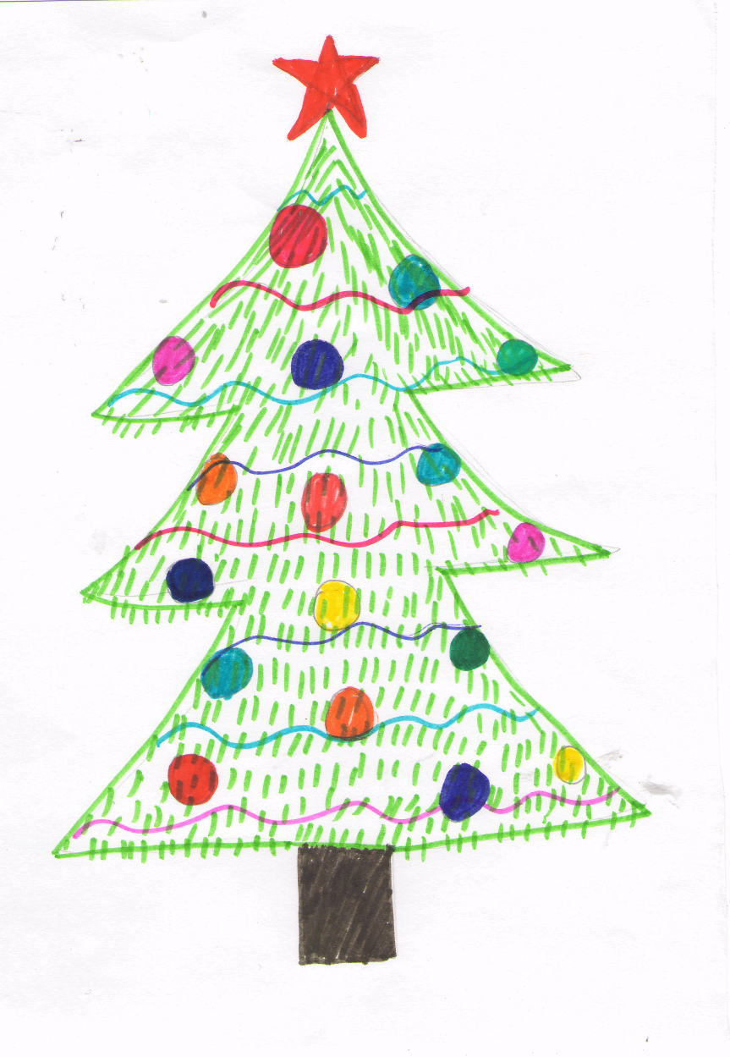
(Fairy-tale)
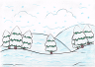
Once upon a time there was a small __________ .
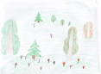
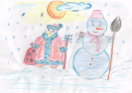
The fir-tree grew in a big __________ on a round

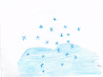
________ . It was ____________ and it was very cold.
It was a lot of white _________around the fir-tree.

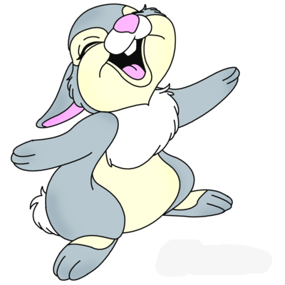
The _________ looked sad because she had no friends.
One day a ________ came to the fir-tree and asked “Why are you so sad”?
“I am alone” answered the fir-tree.
“Poor thing” said the hare and ran away.
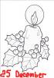
On the 24th of December before ________ a lot of
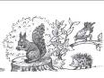
_______ came to the fir-tree.

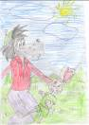
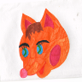
There was a _____and a_____, and a _________ .
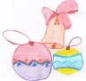
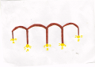
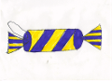
They had a lot of presents for the fir-tree:
_________ , ___________ and a __________. They decorated our fir-tree with toys and danced around her.
The _________ was very happy because it was Christmas when all wishes come true.
The End

If you are unhappy and have no friends make a toy and give this present to any person who needs your help. And you’ll get a new friend.

Answers:
1 – fir-tree; 2 – forest; 3 – forest-glade; 4 – winter; 5 – snow; 6 – fir-tree; 7 – hare; 8 – Christmas; 9 – animals; 10 – wolf/hare; 11 – fox; 12 – baubles; 13 – lights, 14 – cracker; 15 – fir-tree.
Resources
http://www.mamusik.ru/upload/userimages/dkxktqoglqhbhrpeqmvuo.png
http://festival.1september.ru/files/articles/41/4157/415791/img2.jpg

